## - Flood Management Measures in Damodar valley

In order to control floods and other related problems, the Central Government, in consultation with the state governments of erstwhile Bihar (now Jharkhand) and West Bengal, worked out a unified development project for the Damodar Basin. The Damodar Flood Enquiry Committee suggested a comprehensive plan. This plan was based on the memorandum submitted by W.L. Voorduin, an engineer with the Tennesse Valley authority (TVA) in the USA. The Damodar Valley Corporation (DVC) was established on 18th February, 1948 to execute the Damodar Valley Project.

The multiple objective of Voorduin’s Plan of flood control, irrigation, power, etc. in the valley had been sought to be achieved principally through a set of reservoirs at 8 (Eight) sites on Damodar and its tributaries viz. at Tilaiya, Maithon and Balpahari on the Barakar river; Bokaro on Bokaro river; Konar on the Konar river and the Panchet, Aiyer and Bermo detention dams on the Damodar itself. However, on account of financial and other reasons, the participating governments decided to implement the unified scheme in two phases. In the first, only 4 dams viz. Tilaiya (1953), Konar (1955), Maithon (1957) and Panchet (1959) were constructed by DVC. Tenughat dam was constructed by Government of Bihar (undivided Bihar). Due to non-availability of land up to the Design level of Tenughat dam no flood storage could be provided in this dam. This dam is not included under the purview of DVRRC as far as the day-to-day reservoir operation is concerned. Heavy releases from the dam during high floods. Sometimes this tends to upset the reservoir operation of Panchet and Maithon Dams. However, the Tenughat dam authorities under the present limitations make every effort to minimize the flood releases from Tenughat. A pick up structure-Durgapur barrage-was constructed downstream of the 4 dams in 1955 with head regulators for canals on either side for feeding an extensive system of canals and distributaries.

*(Ref: Regulation Manual for Damodar Valley Reservoirs- Year 2002)*

Table 10: Salient Features of Upstream Storages of Durgapur Barrages

| **Features** | | **Tilaiya** | **Konar** | **Maithon** | **Panchet** |
| --- | --- | --- | --- | --- | --- |
| General | Inauguration | 21.02.1953 | 15.10.1955 | 27.09.1957 | 06.12.1959 |
| River | Barakar | Konar | Barakar | Damodar |
| District | Koderma | Hazaribagh | Dhanbad | Dhanbad |
| State | Jharkhand | Jharkhand | Jharkhand | Jharkhand |
| Hydrological | Catchment Area  (km2) | 984 | 997 | 6293 | 10966 |
| Avg. Annual  Precipitation  (cm) | 112 | 132 | 114 | 114 |
| Avg. Annual  Runoff (MCM) | 432 | 555 | 2700 | 4539 |
| Structural | Type | Concrete  Gravity | Composite[1] | Composite1 | Composite1 |
| Maximum Height  above  foundation (m) | 30.18 | 57.60 | 56.08 | 47.85 |
| Overall Length  (m) | 365.76 | 3682.03 | 4426.76 | 6777 |
| Type of Spillway | Ogee | Ogee | Ogee | Ogee |
| Crest gate type | Tainter | Tainter | Tainter | Tainter |
| Crest Gate  Number | 14 | 9 | 12 | 15 |
| Crest Gate Size  (m x m) | 9.14 X 3.05 | 10.36 X 9.91 | 12.19 X 12.5 | 12.19 X 12.5 |
| Undersluice type | Butterfly | Vertical lift | Vertical lift | Vertical lift |
| Undersluice  Number | 2 | 2 | 5 | 10 |
| Undersluice  Size (m x m) | 1.66 X 1.02 | 2.29 m  diameter | 1.73 X 3.05 | 1.73 X 3.05 |
| Reservoir | Dead Storage  Level (m) above  MSL | 363.32 | 410.57 | 132.59 | 119.48 |
| Dead Storage  (MCM) | 75 | 35 | 93 | 106 |
| Conservation  Level (m) above  MSL | 368.81 | 425.81 | 146.31 | 124.97 |
|  |  |  |  |  |
| Conservation  Storage (MCM) | 141 | 175 | 441 | 169 |
| Max. Utilizable  Flood  Management  Level (m) above  MSL | 372.47 | 427.94 | 150.90 | 131.10 |
| Flood  Management  Storage (MCM) | 165 | 38 | 334 | 434 |
| Power | Installed  Capacity | 4 MW | Nil | 63.5 MW | 80 MW |
| Installed  Capacity | Vertical  shaft  Francis | --- | Horizontal  Shaft Francis | Vertical shaft  Kaplan |
| Maximum Head  (m) | 19.51 | --- | 38.71 |  |

Existing Projects Namely Konar, Tilaiya, Maithon, Panchet and Tenughat and a Proposed Project for flood moderation in lower Damodar basin is presented below.. The FRL of the proposed Project is tentatively fixed at RL.232m

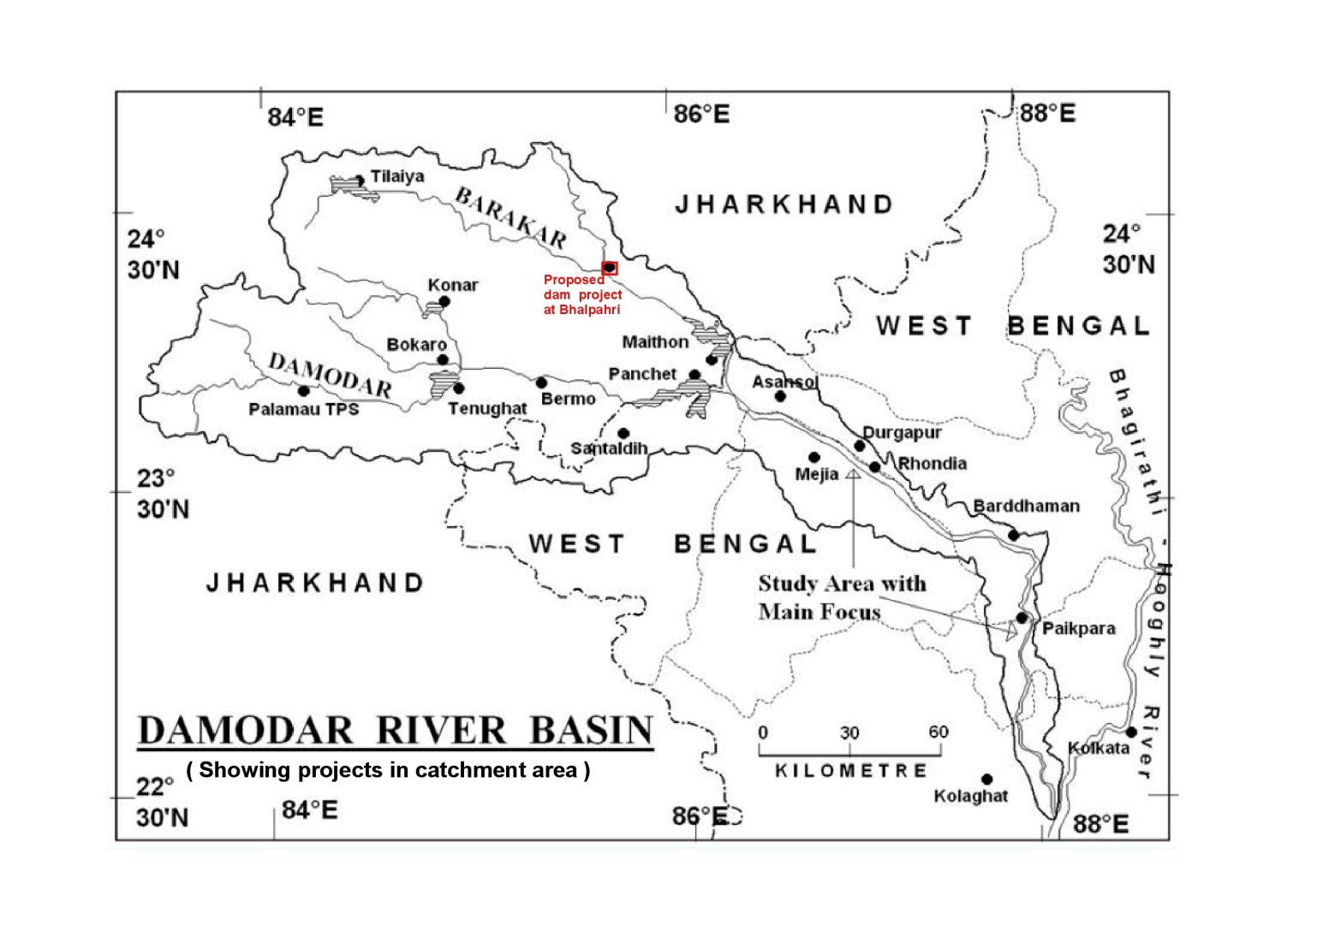

Figure 14: Map Showing Existing Projects Namely Konar, Tilaiya, Maithon, Panchet and Tenughat .A new Project has been identified on Barkar river in the upstream of Maithan dam. The catchment area intercepted by this project is about 5168 sqkm. The FRL is tentatively fixed at 232m and Gross storage capacity is 45175 Ham.The Average bed level is about 200m.The reservoir map and the catchment map of this project are given below.This project will be use ful for flood moderation in combination with Maithan dam.

**Belphari reservoir contour map**

